**Literacy/Topic** This term our topic is about all things creepy crawly. We will begin by finding out about our favourite minibeast and writing fact files. We will then focus on a different minibeast each week; ladybirds, caterpillars and butterflies, bees, worms and snails, and finally spiders. We will explore some brilliant stories such as The Bad Tempered Ladybird, Aaaarrggghhh Spider and Superworm. We will find out about why bees are so important to us and think about ways we can help them.

***Marvellous Minibeasts***

***Weekly Home Learning***

Here is an outline of the home learning activities for this half term. Your child can choose to complete one of these activities each week. Please sign the grid to show that your child has done an activity and send in their home learning book every **Monday** with any form of recording your child has done (e.g. photo, videos, pictures, writing, children’s quotes, or creations).

**Please can all reading folders be in school everyday**

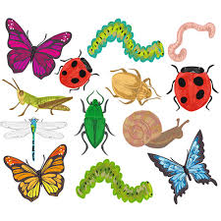

**Murphy Class**

**Term 5**

**Number bonds to 10**

(From week 3 onwards) Play one of the number bonds games. Use the printed game and a dice or get super speedy using the online game

<https://wordwall.net/resource/301920/maths/number-bonds-to-10-pairs-game>

**Word Play**

How many words can you make using the letters from the word ‘caterpillar’. If you make letter tiles or cards with these letters on, it will make it easier for you. Write the words down that you make.

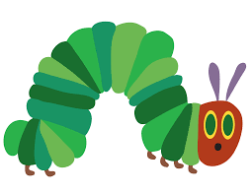

**Create your own Superworm**   
Using some long socks or tights, the more colourful the better, create a Superworm character. Stuff the sock with newspaper, add elastic bands around the length of the body and get creative with adding your own detail!

**Maths** This term we will be exploring how number 10 is made up and using these number bonds to solve problems. We will be learning about odd and even numbers and how amounts can be shared fairly. We will be using lots of practical equipment to help solve addition and subtraction questions.

**Let’s get Cooking!**

Think about your favourite minibeast and see if you could find a recipe to make something that looks like it. Maybe cheesy snails, ladybird biscuits or fruit caterpillar kebabs!

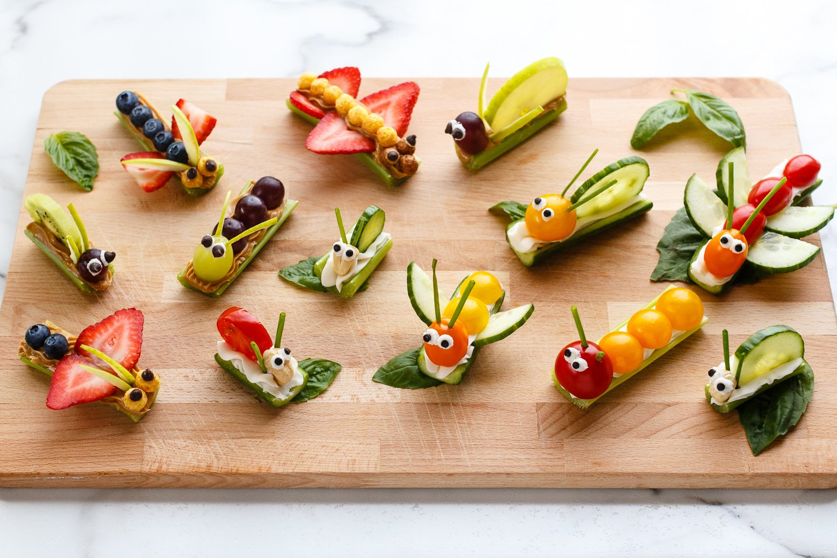

**Minibeast Adventure**

Go out on a bug hunt! Go on a walk that might include several different habitats e.g. meadow, woodland, stream. How many minibeasts can you spot? Remember to be very gentle. Record in your book what you see.

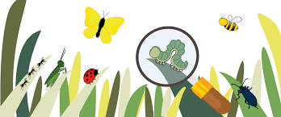

**Art** We will be using lots of skills and techniques to create some beautiful bug art. We will make symmetrical butterfly pictures, use dough and clay to model worms and snails and paint ladybird *pebbles* – *if anyone has any to donate we’d love them!* We will look at Henri Matisse’s The Snail and use it as inspiration to create our own masterpieces.

**Bug Research**

Find out some information about a particular minibeast. Write some super interesting facts about what you have found out.

**Please RETURN THE HOME LEARNING BOOK EVERY MONDAY, even if you have not completed an optional task.**

**PE will be on Mondays. Forest school will continue to be on Fridays**