f

Create an Under the Sea Show Box. At the end of the term, we will show our different crafts.

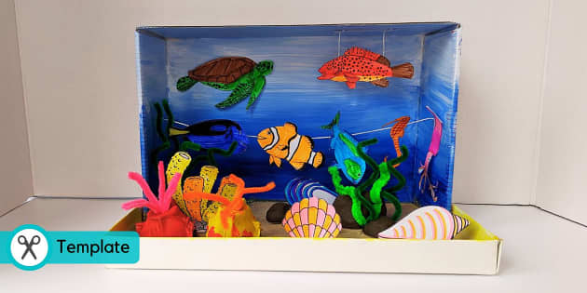

Create a poster abut how to stay safe around water.

Have a look around your home and find 2 things that you think will float and sink. Write about your investigation.

***Weekly Home Learning***

*Please record your* ***daily reading*** *in the diary, practise reading the key vocabulary for the week. You can also complete one of the optional activities below:*

***Under the Sea***

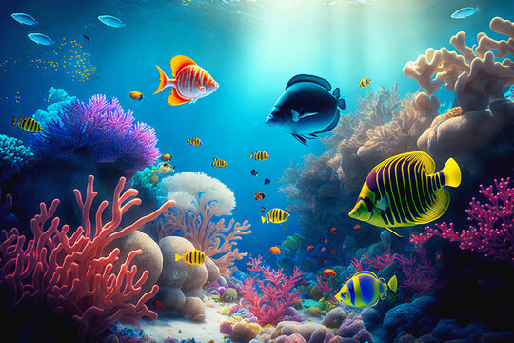



**Donaldson Class  
Term 5**

**English We will be learning to:**

* Apply our phonics to spell words correctly.
* Write a fact file on an ocean explorer
* Write descriptive sentences/paragraphs based on *Rainbow Fish*

**RE We will be learning to:**

* Discuss the significance of Shabbat
* Explain what is special to the Jewish community during Shabbat
* Describe behaviours during Shabbat

**Geography We will be learning to:**

* Locate the world’s oceans
* Discuss the impact climate change has on the ocean and its habitats
* Research about Darwin’s Ocean voyages.

**Science We will be learning to:**

* Sort between what is living, dead or never alive.
* Describe the seven life processes.
* Identify different habitats and food chains.

**Maths We will be learning to:**

* Draw and describe 2D shapes
* Identify shapes with lines of symmetry
* Add and subtract numbers to 100 by crossing ten

|  |  |  |
| --- | --- | --- |
| ***Key Vocabulary/Spellings*** | | |
| **Week 1 – Soft C**  rice  nice  race  face  cell  circle | **Week 2 – ‘wr’**  write  wrong  wriggle  wrist  wreck | **Week 3 – ‘kn’**  knee  knight  knock  knife  know |
| **Week 4 – ‘+y’**  sleepy  happy  sunny  fluffy  family | **Week 5 – ‘+ing’ words**  singing  playing  barking  sleeping  doing | **Week 6 – ‘+ing’ words**  sitting  swimming  getting  running  spelling  stopping |

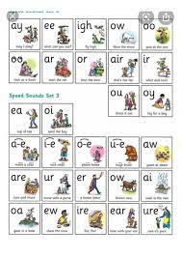

TT Rockstars/Numbots: You all have been given a username/password. If you need help, please speak to Miss Morton. I will be printing any certificates earnt on a Thursday and presenting them on a Friday in class to take home.

**Creative Writing**: Write a story based on this picture!

**Example:**

One sunny morning, there lived a girl called Flo. Flo loves the ocean and spends most days diving deep to discover life under the sea.

**Please RETURN THE HOME LEARNING BOOK EVERY MONDAY, even if you have not completed an optional task.**